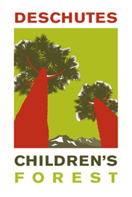
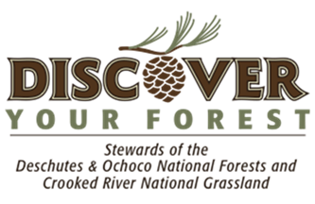
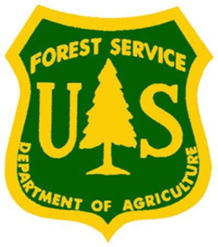

Marketing Internship

Summary:
The Deschutes Children’s Forest Marketing intern will play an essential and active role in assisting Deschutes Children’s Forest team with heightening awareness and engagement within the community. The intern will be provided the opportunity to better understand marketing and social media efforts of a non-profit organization. This position is open to high school and college students.
Duties include but not limited to:
- Assist with design, production and distribution of marketing and educational program materials
- Explore and expand social media efforts
- Provide assistance with DCF website enhancements
- Market and promote various DCF events throughout community
Duration:
Intern will be required to complete between 100-150 hours over 8-10 weeks. The hours are flexible, but may require occasional weekend and evening events.
Stipend:
Intern will receive a stipend of $1,000 and has the option to gain credit through their high school or university.

For more information contact Phil Meagher, Discover Your Forest’s Volunteer and Stewardship Coordinator at 541-383-5530 or phil.meagher@discovernw.org

