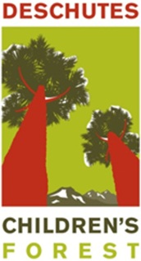
Deschutes Children’s Forest (DCF)
Updated 8-5-13
Partner and Site/Facility Application
The Deschutes Children’s Forest has developed this form to accept applications from prospective DCF Partners and for DCF Sites and Facilities.
Overview
The Deschutes Children’s Forest (DCF) is an exciting new initiative that is just getting underway in Central Oregon. Rather than being confined to (or defined by) a particular stand of trees, the Deschutes Children’s Forest is actually a much broader network of outdoor places and programs dedicated to moving all children along a continuum of learning, exploration, and healthy living through engagement with nature. Our goal is to address “Nature Deficit Disorder” and move children, in age appropriate activities, from curiosity to awareness, understanding and ultimately engagement.
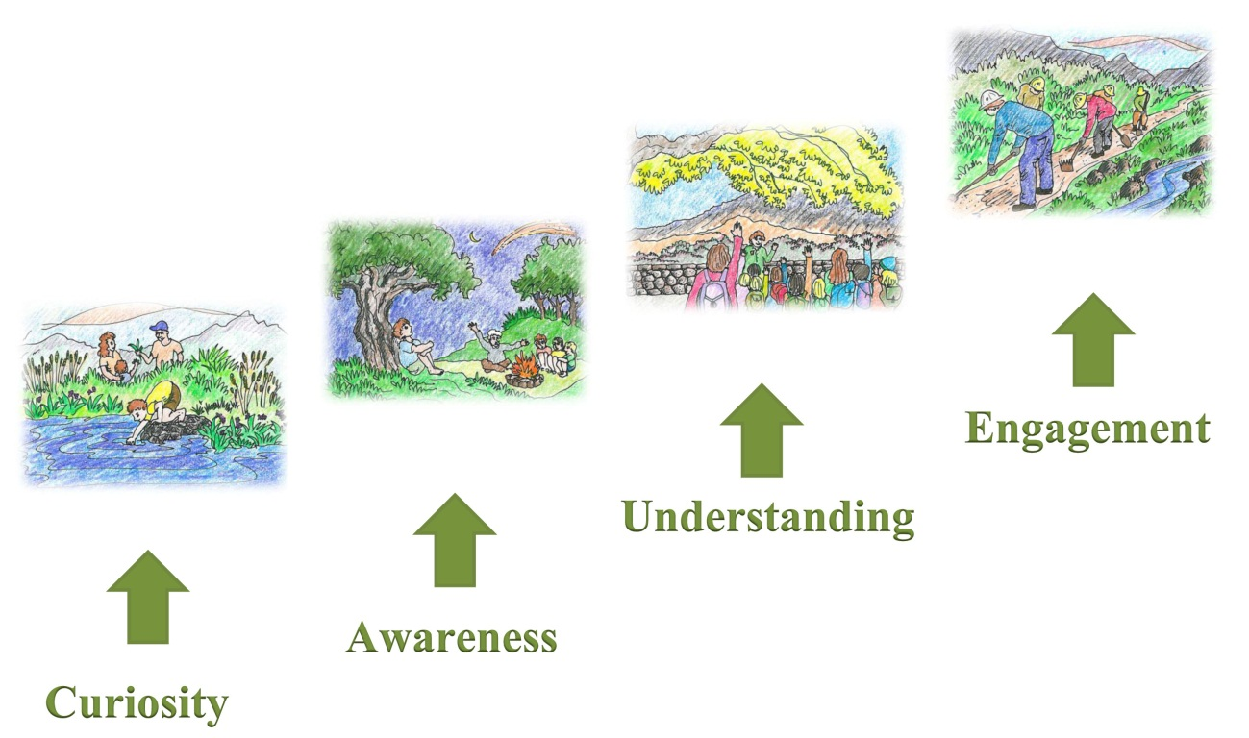

The Deschutes Children’s Forest (DCF) operates under a unique model where the vast majority of the programs, activities and events are provided and operated by DCF Partners working both individually and collectively. This model seeks a balance between organizational autonomy and the synergy that comes from a high level of collaboration. The DCF operates as a project under Discover Your Northwest (DYNW) which gives it 501(c)3 nonprofit status. The DCF has an Advisory Board and a single staff person who helps oversee operations and coordinates the work of several DCF committees. Fundraising and grantwriting are done on behalf of the various DCF programs and sites. Currently, most of the DCF Partners has a seat on the DCF Advisory Board which operates under the ultimate jurisdiction of Discover Your Northwest.

Partners
Deschutes Children’s Forest Partners currently include the following:
- Deschutes National Forest*
- Discover Your Forest (DYF)/DYNW*
- Bend-La Pine School District*
- Redmond School District*
- Sisters School District*
- High Desert Education Service District (HDESD)*
- Bend Park and Recreation District*
- Redmond Area Park and Recreation District*
- High Desert Museum*
- Upper Deschutes Watershed Council*
- Wolftree*
- The Environmental Center*
- Wildheart Nature School
- Camp Tamarack (On Belay TY)
- Central Oregon Pediatric Associates (COPA)*
- Mosaic Medical*

*Indicates that the DCF Partner is also on the DCF Advisory Board

Core Principles and Values
- All children in Central Oregon can benefit from experiences in the natural world
- Accessible opportunities with nature must be provided for children of all abilities, backgrounds and ages
- Nature based curriculum strengthens and diversifies core education programs
- Lifelong health and wellness habits are developed through engagement with nature based programs, activities and experiences
- Leadership skills and possible future career paths for youth can be identified and encouraged through nature-based activities and learning opportunities
- Stewardship and sustainability are core ethics learned by children in Central Oregon through guidance by experienced adults and engagement with the natural world.
- Collaboration is essential to our success

Geographic Boundary
The geographic footprint of the Deschutes Children’s Forest is the area in and around Deschutes County and its associated public lands (and will include parts of Jefferson, Crook and Northern Klamath Counties in the future).

Advisory Board Members vs. DCF Partners
DCF Partners are organizations whose mission and core programs (if applicable) align with DCF’s mission and Priority Initiatives and who wish to be identified as part of this exciting initiative. While the founding DCF partners represent a broad cross-section of DCF’s priority initiatives and geographic areas, other organizations in Central Oregon may apply to become DCF partners. The DCF Advisory Board is responsible for accepting (or rejecting) new applications. At this time, there is no limit to the number of organizations that can become DCF Partners.
DCF Advisory Board Members may be designees from DCF partner organizations or members of the community, unaffiliated with a partner organization**. The Advisory Board is comprised of 9-20 members who collectively, meet the following criteria:
- Provide well-rounded representation from the core areas of education (K-12), conservation education, land management, recreation, and health
- Provide representation for DCF’s geographic areas (Bend, Redmond, Sisters, La Pine, Jefferson County, Northern Klamath County, and Crook County) in each of the core areas listed
- Provide the skills and resources necessary for the work done by DCF Committees
**Members of the community may be considered to be members of the Advisory Board if they can provide a skill necessary for the work of the DCF Committees.
Fundraising and DCF Resource Development
The DCF Fundraising Committee has 5 responsibilities:
1. Work with the new “Friends” group, Discover Your Forest to determine specific fundraising roles
2. Work closely with DCF program providers to ensure that all fundraising activities are collaborative and not competitive among partners. Utilize tiered fundraising approach (see table below)
3. Identify opportunities for grants and other outside funding
4. Work with both the Program Committee and the Sites and Facilities Committee to strategically coordinate Deschutes Children’s Forest Partners to have conversations that allow us to identify and prioritize particular funding needs and sources
5. Write grants as needed

Grantwriting Approach
Tier 1 – new $ | Tier 2 – existing relationship | Tier 3 – unique relationship
These would be new funding sources where the best approach is from a coordinated DCF proposal; specific components to be developed by the Fundraising Committee in collaboration with the Program Committee and Sites and Facilities Committee to determine grant deliverables. | These are funding sources where there is an existing relationship and one or more DCF Partners has already received funds. DCF Partners are encouraged to develop coordinated approaches to these funders whenever possible. The Fundraising Committee will examine funding opportunities on a case by case basis to maximize collaboration and limit competition for funding. | These are funding sources where the DCF Partner has a long-standing and unique relationship and adding additional partners or emphasizing the DCF might be seen as diluting the product. The DCF partner will maintain their relationship with the funder to most effectively deliver DCF programs that accomplish DCF goals and objectives.

Roles and Responsibilities
DCF Partners agree to ….
- Act in the best interest of the Deschutes Children’s Forest (i.e. take your organizational “hat” off at the door)
- Exhibit a commitment to move forward the mission and vision of the Deschutes Children’s Forest
- Embrace and support the Core Principles and Values of the Deschutes Children’s Forest
- Provide “added value” to the Deschutes Children’s Forest – this can be in the form of funding, marketing, education, training, volunteering and technical assistance by serving on a DCF Committee and/or helping with a DCF project
- Conduct background checks on all of an organization’s staff and volunteers that come into contact with children
- Adhere to a policy of non-discrimination
- Have a formal safety plan in place for every site (if applicable)

In addition to the roles and responsibilities listed above, DCF Advisory Board members agree to…
- Sign the MOU with Discover Your Northwest dba Discover Your Forest (unless they are a community member, unaffiliated with a partner organization) and establish an MOA with the rest of the DCF Partners (if applicable)
- Make a financial and/or in-kind commitment. An in-kind commitment may include participating on a DCF committee or doing work towards one of DCF’s Priority Initiatives.
- Attend 75% of Advisory Board meetings each year. Advisory Board members representing DCF Partner organizations may send another designee to attend Advisory Board meetings when necessary.

Benefits
- Be a part of an exciting movement that will add value to the work of your own organization and to thousands of children throughout Central Oregon
- Potential funding and/or in-kind support for your programs and activities*
* We use the word potential for a reason – there is no guarantee that your organization will receive funding as a result of its affiliation with the Deschutes Children’s Forest. Those decisions will be determined through the process of prioritization that occurs at the Advisory Board and the DCF Committees - and - whether we are successful with our grant applications.
Application Process
The process for reviewing applications will take between 1-3 months.
- Upon receipt of your application, the DCF Advisory Board will review the application and if the applicant’s organizational mission and core program goals are consistent with DCF principles and values, the applicant will be invited to an Advisory Board meeting for an opportunity to answer any questions.
- Following this initial screening, a DCF Advisory Board member or staff member will conduct any necessary follow-up which may include contacting references, observing programs, or gathering financial information about the organization.
- Once the information has been gathered and reported to the Advisory Board, the applicant will be invited to an Advisory Board meeting for any final questions.
- The Advisory Board will vote at that meeting and notify the applicant.
Deschutes Children’s Forest Partner Application Form

We are applying to become a:  DCF Partner  Advisory Board member

Organization Background
Name of Organization Years in existence?
Primary Contact Title
Address Nonprofit or other status?
City ST ZIP
Phone email
Authorized Signature Date

Narrative Please use 3-4 pages to describe your organization including the following:
- Why you think you are a good fit with the Deschutes Children’s Forest and its emphasis on healthy minds, healthy bodies and healthy forests
- Population served
- Major activities and/or programs that are pertinent to the mission of the Deschutes Children’s Forest
- Capacity to track participants and monitor performance
- Examples of where your organization has worked in partnership with others
- What value you would bring to our efforts to reach all children with meaningful outdoor activities
- Vision for the future of your organization if able to expand programming

Legal/PR Please use as much space as needed to provide the following information:
- Is your organization currently facing any litigation? If so, please describe.
- Describe your organization’s current liability insurance and confirm that it is transferrable to others (or describe why this is not applicable).
- Describe your process of conducting background checks on volunteers that may be in contact with children
- Describe your “safety plans” for pertinent programs (or describe why this is not applicable).

References (if applicable) Please list the names and contact information for three references that can speak to the quality of your programs.

Attachments Please feel free to include brochures or any additional materials that will help us to better understand your organization.

Submittal of Applications Proposals can be submitted at any time to bruce.abernethy@bend.k12.or.us. For questions contact Bruce Abernethy at 541-355-1024.

Deschutes Children’s Forest Site/Facility Application Form

We are nominating the following to become a:  DCF Site  DCF Facility

Nominating Organization/Individual Background
Name of Organization Years in existence?
Primary Contact Title
Address Nonprofit or other status?
City ST ZIP
Phone email
Authorized Signature Date

Narrative Please use 1-2 pages to describe the proposed site/facility including the following:
- Why you think this location/facility is a good fit with the Deschutes Children’s Forest and its emphasis on healthy minds, healthy bodies and healthy forests
- Population served – currently and proposed (if applicable)
- Major activities and/or programs that currently (or could) take place at this site/facility that are pertinent to the mission of the Deschutes Children’s Forest
- What is the site capacity? How many people can be there at any one time?
- What amenities are currently in place? (e.g. shelter, toilets, parking facilities, trails, etc.) Is it accessible? To whom? wheelchair, visually impaired, etc.
- Vision for the future of this site/facility if additional funding could be secured

Pictures Please include several photos to help us understand the capacity and potential of the proposed site/facility.

Legal/PR Please use as much space as needed to provide the following information:
- Who has ownership of the site/facility? Are there any issues associated with access to the site/facility?
- Describe your organization’s current liability insurance and confirm that it is transferrable to others (or describe why this is not applicable).
- Describe transportation logistics including parking and bus turnaround (if applicable)
- Describe “safety plan” for the site/facility (if applicable)

Submittal of Applications Proposals can be submitted at any time to bruce.abernethy@bend.k12.or.us. For questions contact Bruce Abernethy at 541-355-1024.

